|  |  |  |  |  |
| --- | --- | --- | --- | --- |
| HYPERTEXT | | | | |
|  |  | | |  |
| ASSASSINS | | | | |
|  | | GROUP 5 Documentation |  | |

TABLE OF CONTENTS

**Introduction…………………………………. 3**

Introduction 3

Glossary of Terms 4

Problem Statement 7

Statistics Supporting Problem Statement 8

Solution Statement 11

Solution Impact 14

POC – Proof of Concept 17

UMLs (Use cases, erd) 22

System Architecture 23

System Requirements 24

Website Mockup 27

References 31

# Introduction

This group consists of 4 members:

* Nhlakanipho Ndlovu (219072870)
* Kwenzokuhle Mhlongo (221010782)
* Amara Monakali (222137555)
* Jackson Nyanstumbu (220000296)

# Glossary of terms

* **Municipality: A local governing body responsible for the administration of a specific geographic area or community.**
* **Website: A collection of web pages accessible through the internet that provides information and services related to the municipality.**
* **CV (Curriculum Vitae): A document that outlines a person's educational background, work experience, skills, and accomplishments, typically used when applying for employment.**
* **User: An individual who accesses and interacts with the municipality website to avail services, access information, or participate in community activities.**
* **Administrator: A privileged user with elevated access rights who manages and maintains the municipality website, including user accounts, content, and system configurations.**
* **Issue Reporting: The process of notifying the municipality about problems or concerns within the community, such as infrastructure issues, public safety concerns, or service disruptions.**
* **Utility Bill Payment: The process of submitting payments for essential services like water and electricity bills through the website, offering convenience and online transaction options.**
* **Community News: Information and updates about events, announcements, initiatives, or projects happening within the municipality, aimed at keeping residents informed.**
* **Educational Resources: Online materials, guides, or resources related to skill development, career guidance, educational opportunities, or training programs available for community members.**
* **Discussion Forums: Online platforms or spaces where community members can engage in conversations, exchange ideas, seek advice, or discuss matters related to the community.**
* **User Registration: The process by which a user creates an account on the municipality website, providing necessary information to access personalized features and services.**
* **Login: The process of authenticating a user's identity by providing valid credentials (username and password) to gain access to their account on the municipality website.**
* **Responsive Design: A design approach that ensures the website's layout and content adapt and display appropriately across various screen sizes and devices.**
* **Database: A structured collection of data organized and stored electronically, typically used to store and retrieve information efficiently.**
* **Analytics: The measurement, collection, analysis, and reporting of website data to gain insights into user behavior, trends, and performance metrics.**
* **Accessibility: The design and implementation of the website to ensure that it can be used and accessed by individuals with disabilities, complying with accessibility guidelines and standards.**
* **Security: Measures and protocols implemented to protect user data, prevent unauthorized access, and maintain the confidentiality and integrity of information shared on the website.**
* **Privacy: Policies and practices that protect the personal information and data of users, outlining how the municipality website collects, uses, and safeguards user information.**
* **Scalability: The ability of the website to handle increasing amounts of data, traffic, and user interactions without compromising performance or functionality.**
* **Content Management System (CMS): A software application or platform that enables the creation, editing, and management of digital content, such as website pages, documents, and multimedia.**

**This glossary provides definitions for key terms related to the municipality website, helping users understand and familiarize themselves with the specific terminology used on the website.**

# Problem statement

* The current state of our community lacks a centralized platform for members to access vital information, report community issues, and conveniently manage their utility payments. This absence hinders residents from effectively drafting CVs, staying informed about community updates, and accessing necessary services. Consequently, there is a pressing need to develop a comprehensive municipality website that addresses these challenges, enabling community members to easily draft CVs, report local issues, and conveniently pay for water and electricity bills. And further try to improve the satisfaction of the citizens living in that municipality. There is also no denying the power and influence of technology and social media in our lives so its very important that we integrate it into places that need it for convenience, such as this website.

# Statistics supporting Problem Statement

**Issue on Citizen Satisfaction on Overall service delivery**

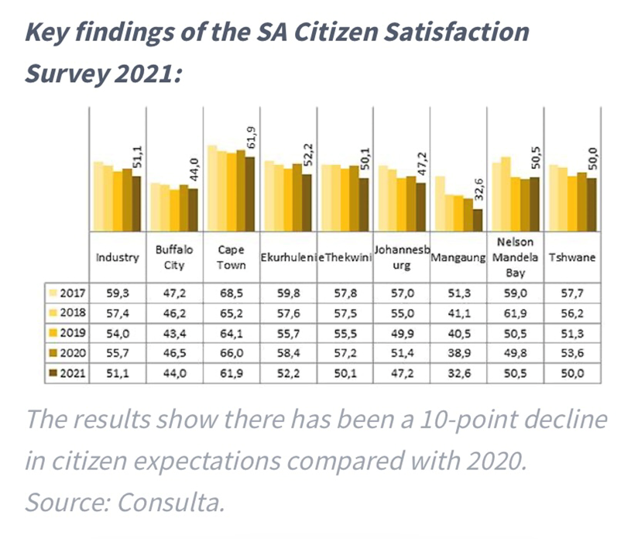

* The quality of service delivery in South Africa is below subpar and measured by the satisfaction of the community of that specific municipality.
* “The overall Citizen Satisfaction level, as an average across all metros, is low at 51,1 – further declining from 55.7 in 2020 and reaching the lowest point in five years. This score indicates that citizens' satisfaction levels are exceptionally low, and trust in the municipalities' ability to deliver is severely eroded.” source property24.com

**Issue on unemployment**

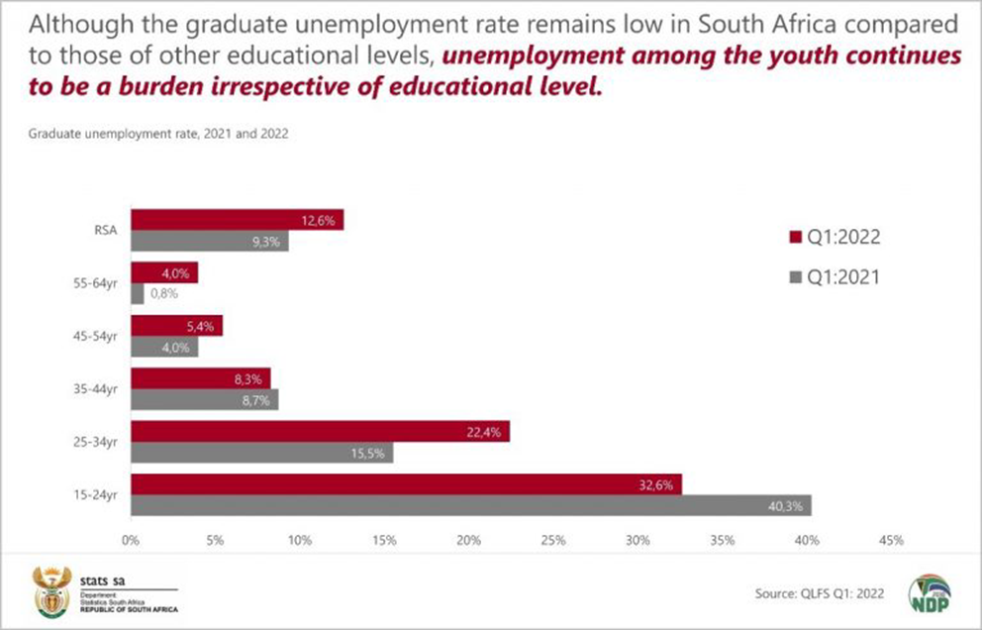

* The unemployment rate as of this year is currently sitting at 32.7%
* Most schools in South Africa do not teach learners about important life skills they will need in the future such as how to draft a CV and how to build their resume for future employment.

**Issue on Long queues**

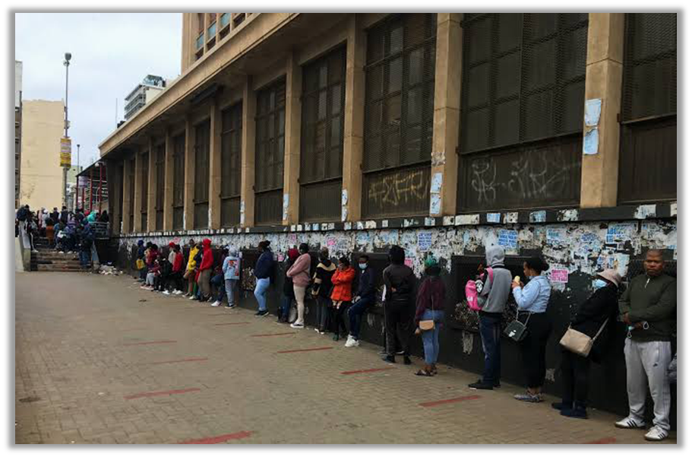

* All South African citizens are aware of the long queues we experience for municipal services... Standing in these long queues can be very tiresome and time-consuming
* Most of these governments ranches might experience backlog or “system offline” and they don’t even let people know beforehand which can cause irritation to the people standing in those queues.

# solution statement

We personally cannot solve the problems that we have listed above, only our government can but we can provide some information to the users of our website.

We want to create a user-friendly website for people within a specific municipality where they will be able to access services and updates on those services in the community.

Here are a few ways in which our website can help address community issues:

* Information and Awareness: Our website can serve as a hub of information, providing updates, news, and resources related to community issues. So with the example of Service delivery, we can provide how are uses inside of the changes/Updates of the issues with the service delivery within that specific municipality It can educate community members about various topics, initiatives, and programs aimed at resolving specific problems.
* Reporting and Feedback Mechanism: A website can incorporate a reporting system where community members can easily submit complaints, concerns, or suggestions regarding issues in the community. We hope to create a platform where community members can report issues and faults within the community onto the website helping the people in that community to run more efficiently. This can help streamline the process of addressing and resolving problems by providing a structured way for community members to communicate their issues to the relevant authorities or organizations.
* Resource Directory: The website can include a comprehensive directory of resources available in the community, such as local services, support organizations, and government agencies. This can help individuals easily access the assistance they need and connect with relevant stakeholders who can help address their specific issues.
* Online Services and Payments: If applicable to the specific issue, the website can provide online services or payment functionalities. For example, if there are utility bill payment issues, community members can conveniently pay their bills online through the website, reducing the need for physical visits or paper-based transactions.
* Education: The website can offer educational resources, tutorials, or workshops on topics related to community issues such the unemployment issue, we will provide resources like how to draft a CV. This can empower community members with knowledge and skills to address the problems they face.

Overall, our website can enhance community engagement, streamline communication, and provide a centralized platform for addressing and resolving issues.

# solution impact

* Improved Access to Information: The website will provide community members with easy access to important information, such as guidelines and resources for drafting CVs, community updates, and relevant news. This will empower individuals with the knowledge they need to create effective CVs and stay informed about community matters.
* Enhanced Reporting and Issue Resolution: The website's reporting system will enable community members to report issues promptly and efficiently. This streamlined process will ensure that community concerns are documented and addressed in a timely manner, fostering a sense of accountability and responsiveness from local authorities.
* Convenient Utility Payments: By incorporating online payment functionalities, the website will allow community members to conveniently pay for water and electricity bills. This will eliminate the need for physical visits or paper-based transactions, saving time and effort for residents and improving overall efficiency in utility payment processes.
* Skills Development and Empowerment: The website can provide educational resources, guides, and templates for CV drafting, helping community members enhance their employability. By improving their CV writing skills, individuals will have better chances of securing employment and advancing their careers, leading to economic empowerment and improved livelihoods.
* Resource Directory and Support: The website's comprehensive resource directory will provide information on local services, support organizations, and government agencies. This will enable community members to easily access relevant assistance and support, promoting a stronger support system within the community.
* Positive Community Image: A well-designed and functional municipality website demonstrates a commitment to transparency, efficiency, and community welfare. This can enhance the overall image of the municipality, instill confidence among community members, and attract potential investors or stakeholders who value an engaged and well-managed community.
* Scalability: The website's infrastructure and design should be built with scalability in mind. As the community grows and the website gains traction, it should be able to accommodate an increasing number of users and handle higher volumes of data and traffic. Scalability ensures that the website can continue to serve the expanding needs of the community without compromising its performance or user experience. This flexibility will allow the website to adapt and scale up as the community's requirements evolve over time, ensuring its long-term effectiveness and sustainability.

By implementing our municipality website with the features and functionalities, the community will experience improved access to information, streamlined issue resolution, convenient utility payments, skills development opportunities, increased community engagement, and a positive community image. These impacts will contribute to a more empowered, informed, and connected community, ultimately enhancing the overall well-being and development of the municipality. And users will need this website to do all those things for their convenience.

# Poc – proof of concept

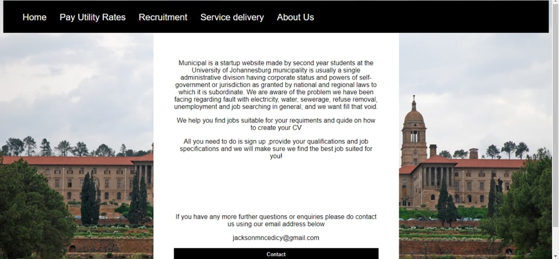**Figma**

Website Homepage

**Background story**

We, as a group, are all residents of different communities that we call home. Over the years, we have all witnessed the challenges and struggles faced by our neighbors when it comes to accessing information, reporting issues, and managing essential services like water and electricity.

As we were talking, we shared our experiences and realized that many of us had encountered difficulties in drafting professional CVs, finding the right resources, and staying informed about community matters. We felt a desire to bridge these gaps and empower our community members with the tools they need to thrive.

Inspired by our conversations, we decided to take action and create a solution that could make a meaningful impact on our community. That's when the idea for the municipality website was born. We envisioned a centralized platform where individuals could find guidance on drafting CVs, report issues that needed attention, make utility bill payments conveniently, and access essential resources. Together, we formed a dedicated team committed to creating a website that would serve as a one-stop solution for our community's needs.

We collaborated to build a user-friendly and intuitive platform that would be accessible to all residents, regardless of their technological proficiency.

Throughout the development process, we remained focused on our mission: to better our community with the tools and resources needed to thrive. We tested each feature, refining and improving it based on user feedback, until we were confident that the website would meet the diverse needs of our community members.

Finally, after months of dedication and hard work, the municipality website is launched. Our vision of providing accessible information, streamlined issue reporting, convenient utility payments, skills enhancement, community engagement, and resource accessibility was now a reality.

As the website continues to grow and evolve, we hope to be proud of the positive impact it will make. We hope to see community members gaining confidence in drafting their CVs, reporting issues with ease, making seamless utility bill payments, engaging in constructive discussions, and accessing valuable resources that enhance their lives. We hope to expand the website's features and foster a sense of empowerment, connectivity, and opportunity for the users of the website.

For our design we used the programming languages HTML, CSS, Javascript and PHP to design and build our website because those languages are best to create a good looking and interactive website. It took a long time to come up with how we would design how website. We wanted it to look professional and neat. And we wanted to create a website that when you click a certain button, it directs you to a certain tab seamlessly and it works. We used a monochromatic theme to make our website look professional.

1. Homepage: We wanted a user-friendly homepage that highlights the key features and functionalities of the website, which would include a brief introduction to the website's purpose, emphasizing its role in providing information, facilitating issue reporting, and enabling utility bill payments.

2. CV Drafting Section: Then we wanted a dedicated section will showcase sample CV templates and provide step-by-step guidance on how to create a compelling CV. Users will have the opportunity to follow the instructions, customize the templates, and preview their CVs. This section will demonstrate the website's educational resources and assist users in improving their CV drafting skills.

3. Reporting System: For this section we wanted a simplified reporting system where users can submit community issues or concerns. Users will be able to fill out a form with relevant details, such as the issue description, location, and supporting images if applicable.

4. Utility Bill Payment: For this feature a mock utility bill payment system. Users will be able to select their utility type (water or electricity), enter their account details, and proceed to a payment gateway. Although no real transactions will take place, the proof of concept will simulate the payment process and display a confirmation message, indicating a successful payment.

5. Resource Directory: We also wanted to feature a resource directory that provides a list of local services, support organizations, and government agencies. Users can browse through different categories and access contact information or website links for further assistance. This will demonstrate the website's ability to connect users with valuable resources in the community.

**WORKLOAD amongst members**

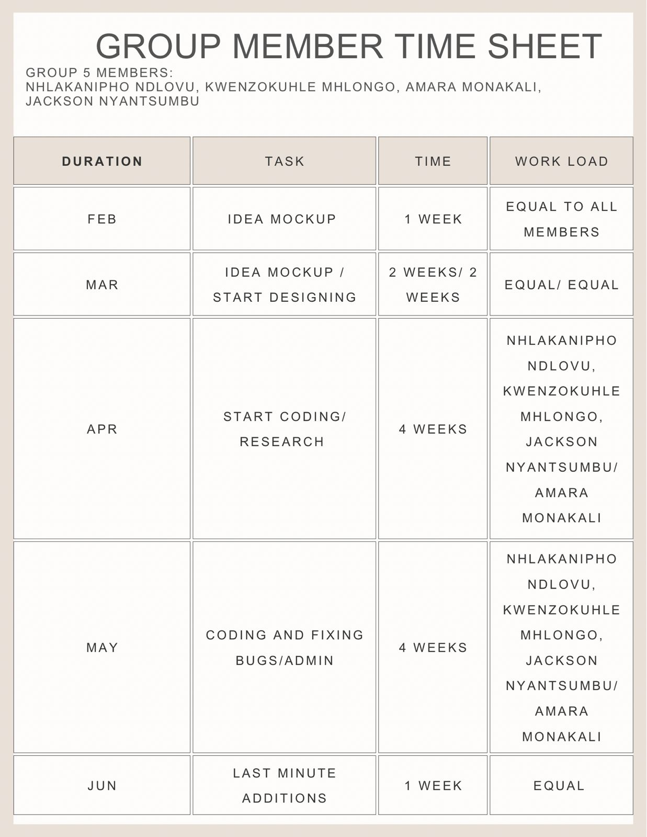

Timesheet

# UMLs (Use cases, erd)

Use Case Diagram

# system architecture

# System requirements

To ensure optimal performance and compatibility, the municipality website should adhere to the following system requirements:

1. Web Browsers:

- Compatible with modern web browsers such as Google Chrome, Mozilla Firefox, Safari, and Microsoft Edge.

- Support for the latest stable versions of these browsers, as well as reasonable backward compatibility with previous versions.

2. Operating Systems:

- Compatibility with major operating systems, including Windows, macOS, Linux, and mobile operating systems like Android and iOS.

- Support for the latest stable versions of these operating systems.

3. Screen Resolutions:

- Responsive design to adapt to various screen sizes, including desktop, laptop, tablet, and mobile devices.

- Optimal viewing experience across common screen resolutions, such as 1366x768, 1920x1080, and 375x667 (for mobile devices).

4. Internet Connectivity:

- Reliable internet connection with reasonable bandwidth to ensure seamless loading and responsiveness of the website.

- Compatibility with both wired and wireless connections, including Wi-Fi and mobile data networks.

5. Accessibility:

- Compliance with accessibility guidelines, such as Web Content Accessibility Guidelines (WCAG) 2.1, to ensure the website is accessible to users with disabilities.

- Support for assistive technologies like screen readers, keyboard navigation, and alternative text for images.

6. Security:

- Implementation of robust security measures to protect user data and ensure secure transactions, including HTTPS encryption for data transmission and appropriate authentication mechanisms.

- Adherence to security best practices, such as secure coding practices, regular security updates, and vulnerability assessments.

7. Compliance:

- Adherence to relevant legal and regulatory requirements, such as data protection and privacy laws, to protect user information and maintain compliance.

These system requirements ensure that the municipality website is accessible, functional, secure, and compatible across different devices and platforms, providing an optimal user experience for community members.

# Website Mockup

## 

## 

# REferences

[college website project report.html](C:\\Users\\amara\\Downloads\\college website project report.html)

# GITHUB LINK